**SELF-DRIVING VEHICLE**



Names

Tushar Mazhar Talukdar -1521237042

1Maksanlina Hossain Mitul -1421803043

Md. Junayet Hossain -1420979043

3.

Department of Electrical & Computer Engineering

North South University

Date

06-08-2020

Senior Design I

CSE499B/EEE499B

Faculty advisor:

Mohammad Ashrafuzzaman Khan

Assistant Professor   
Department of ECE

Fall 2019

# **Abstract**

**Our project is to build a robot car or an autonomous car using raspberry pi, Arduino, and sensors which get command from a Laptop computer to generate the initial path commands. We used sensors to collect data and used mobileNet version-2 for obstacle detection, image processing unit. A raspberry pi is used as the brain of the system and Arduino is used as a slave device to provide the instructions to the car. The car which we made features electric motor driving, each of the wheels is connected to dc motors which gives the orientation of the direction of moving. The car will be able to reach a particular destination by detecting and avoiding any kind of obstacle. In the modern era, the vehicles are focused to be automated and to give human driver relaxed driving. In the field of automobile various aspects have been considered which makes a self-driving car, these vehicles can sense their environment and navigate even rerouting due to traffic, accidents, or construction by way of built-in cameras, radar, sonar, GPS and infrared sensors. Our target by creating an Autonomous Car is to increase efficiency by reducing the possibilities of accidents and to ensure the safety of the passengers as well as the pedestrians. But the best part of our project (Autonomous Car) is that it can serve the applications in the industrial area or for military purposes where the situation is inconvenient, dangerous or impossible to have human operators present, it can also serve special people who have difficulties to drive. Already some country used many types of Autonomous vehicle or Unmanned Ground Vehicle (UGV) for military purposes and other important work. There are many Driverless Or Autonomous Vehicles already exist and are perfectly used in much challenging fieldworks. The future of autonomous vehicles is an ambitious era of safe and comfortable transportation.**

Table of Contents

**Abstract**2

**Table of content** 3

**List of figure**5

**List of tables**……..………………………………………………………………………………………………… 5

**1. Introduction**6

**2. Background**

2.1 automated Vehicle6

2.2 Future of Self Driving car……………………………………………………………………………. 6

2.3 Potential Problems and Potential Benefits…………………………………………………. 7

2.4 Different Stages of Self-Driving car…………………………………………………………….. 8

2.5 Project Aim and Objects…………………………………………………………………………….. 9

2.6 Motivation……………………………………………………………………………………..………… 10

**3. System Design**

3.1 Required Equipment list …………………………………………………………………………. 10

3.2 Component’s Use Cases and Cost ……………………………………………………………. 11

3.3 Block Diagram …………………………………………………………………………………………. 12

**4. Circuit design and setup**

4.1 Raspberry Pi ……………………………………………………………………………………………. 13

4.2 Arduino Uno ……………………………………………………………………………………………. 14

4.3 Sensors ……………………………………………………………………………………………………. 16

4.3.1 Gyro Sensor …………………………………………………………………………………………………………………... 17

4.3.2 IR Sensor ……………………………………………………………………………………………………………………….. 19

4.3.3 Ultrasonic Sensor ………………………………………………………………………………………………………….. 20

4.4 Power Bank ……………………………………………………………………………………………

4.5 Motor Driver L298H Bridge

4.6 Raspberry Pi Camera………………………………………………………………………………..

4.7 Additional Protection Circuit…………………………………………………………

4.8 The Overview of Setup Connection…………………………………………….

**5 Methodology** …………………………………………………………………………………………………

**6 result** …………………………………………………………………………………………………………..

6.1 Result………………………………..

6.2 Problems We Faced………………………..

**7 Discussion**………………………………………………………………………………………

**8 conclusion**…………………………………………………………………………………………………….

**9 References**…………………………………………………………………………………………………….

# List of figures

Figure 1 8

*Figure 2* 11

Figure 3 14

Figure 4: Raspberry pi 15

Figure 5: Pin Configuration of Raspberry Pi 15

Figure 6 16

Figure 7 16

Figure 8: connecting with Arduino Uno 17

Figure 9: Gyro Sensor 18

Figure 10: Working Principle of gyro sensor 19

Figure 11 20

Figure 12 21

Figure 13 21

Figure 14 22

Figure 15 22

Figure 16 23

Figure 17 24

Figure 18 24

# List of table

Table 1 9

Table 2 12

Table 3 13

Table 4 16

Table 5 19

# 1. Introduction

About 1.24 million People are killed in roads every year throughout the world. In  
Bangladesh, according to BUET accident research center the death toll every year is 10-12  
thousand and countless number of people are injured or become disabled destroying so many  
lives and families. The national loss has been estimated around Taka 5,000-7,000 Cores every  
year. Almost 30% of the national healthcare budget is used behind road crash victims  
incurring a financial loss to our economy equivalent to 2% of our national GDP .Autonomous  
system is a solution of this problem.

The motor/vehicle industry has experienced unrest in the course of the most recent decade with advances, for example, driver help frameworks and cross breed/electric drive frameworks created in the fields of mechanical autonomy and hardware advancing into an  
industry overwhelmed by fossil fueled vehicles with constrained insight. This upheaval then  
again, is a long way from being done with electric vehicles still yet to make critical progress  
in the business sector and mechanical usefulness.

# 2. Background

## Autonomous Vehicle

The term automation was coined in the automobile industry about 1946 to describe the increased use of automatic devices and controls in mechanized production lines. Automation can be defined as a technology concerned with performing a process by means of programmed commands combined with automatic feedback control to ensure proper execution of the instructions. The resulting system is capable of operating without human intervention.An autonomous vehicle, or a driverless vehicle, is one that is able to operate itself and perform necessary functions without any human intervention, through the ability to sense its surroundings.

## 2.2 Future of self-driving car

Starting in 2009, Google begins developing its self-driving car project, now called Waymo. In 2014, it reveals a prototype of a driverless car without any steering wheel, gas pedal or brake pedal, thereby being 100 percent autonomous. Companies such as Google, Uber, and Tesla are not the typical car manufacturers, yet they are the top developers of the autonomous technology right now.

The interplay between those tech developers, car manufactures and ride-hailing service providers will redistribute the power and roles in the automotive market as we know it nowadays. By 2013, major automotive companies including General Motors, Ford, Mercedes Benz, BMW, and others are all working on their own self-driving car technologies. Nissan commits to a launch date by announcing that it will release several driverless cars by the year 2020. Tesla and Uber also begin actively exploring self-driving technology, while Apple is rumored to be doing so.

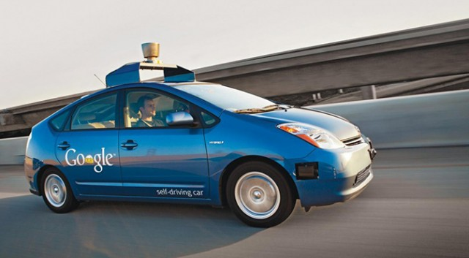

Figure 1

2.3 Potential Problems and Potential Benefits

In the past five years, autonomous driving has gone from “maybe possible” to “definitely possible”. But localization, mapping, scene perception, vehicle control, trajectory optimization, and higher-level planning decisions associated with autonomous vehicle development remain full of open challenges. The challenges range from the technological and legislative to the environmental and philosophical.

* **Weather Conditions:** What happens when an autonomous car drivesin heavy precipitation? If there’s a layer of snow on the road, lane dividers disappear the cameras and sensors find difficulties to track lane markings if the markings are obscured by water, oil, ice, or debris.
* **Traffic Conditions and Laws**: There’s questions about autonomous cars have trouble in tunnels or on bridges. How will they do in bumper-to-bumper traffic or will autonomous cars be relegated to a specific lane? Will they be granted carpool lane access?
* **Accident Liability**: Who is liable for accidents caused by an autonomous car? The manufacturer? The human passenger? The latest blueprints suggest that a fully autonomous Level 5 car will not have a dashboard or a steering wheel, so a human passenger would not even have the option to take control of the vehicle in an emergency.
* **Artificial vs. Emotional Intelligence:** Human drivers rely on subtle cues and non-verbal communication—like making eye contact with pedestrians or reading the facial expressions and body language of other drivers—to make split-second judgement calls and predict behaviors. Will autonomous cars be able to replicate this connection? Will they have the same life-saving instincts as human drivers?

The successful and commercial use of self-driving /driverless /unmanned /automated car will make human life easier. The paper aims to discuss this issue. The main characteristic of self-driving car is transporting people or objects to a predetermined target without humans driving the car. Some benefits are:

* Reduce traffic congestion (30% fewer vehicles on the road)
* Cut transportation costs by 40% (in terms of vehicles, fuel, and infrastructure)
* Improve walkability and livability
* Free up parking lots for other uses (schools, parks, community centers)
* Reduce urban CO2 emissions by 80% worldwide
* More free time as drivers don’t have to drive anymore

2.4 Different stages of self-Driving

The self-driving car can be classified into four levels, as described in Table I. As the levels increase, the extent of the driverless car’s independence regarding operation control increases.

Table I

|  |  |
| --- | --- |
| **Level**  No-automation (Level 0) | **Judgment standard**  The driver completely controls the vehicle all the time |
| Function-specific automation (Level 1) | Individual vehicle controls are automated, such as electronic stability control or automatic braking |
| Limited self-driving automation (Level 3) | The driver can fully cede control of all safety-critical functions in certain conditions. The car senses when conditions require the driver to retake control and provides a “sufficiently comfortable transition time” for the driver to do so. |
| Full self-driving automation (Level 4) | The vehicle performs all safety-critical functions for the entire trip, with the driver not expected to control the vehicle at any time. As this vehicle would control all functions from start to stop, including all parking functions, it could include unoccupied cars. |

Table 1

Due to the maturity of Levels 1, 2 and 3, our projects discusses Levels 4.

2.5 Project Aim and Objective

In our project we aim to make a robot car or self-driving car will be able to function without human driver and run into roads by, detecting and avoiding other vehicles and pedestrians/objects.

Some basic features of our project will be:

* Object Detection
* It will be detect other vehicles and pedestrians/objects.
* Road sign Detection
* Speed Limit Detection
* it will go one place to another place

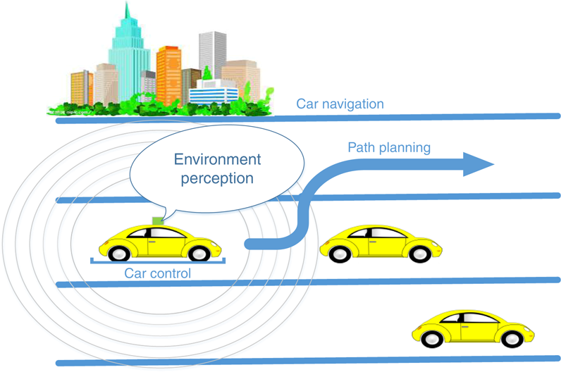

*Figure 2*

## 2.6 motivation

If we take into a consideration that we are using cars only 5% of the time and that human error in driving is the causing too many fatalities, we will come into conclusion that cars itself are not the problem. Instead, we can redefine the problem by how we use cars, or by saying how we actually don't use them. If our cars will be capable to drive without us, why would we keep them idle in front of our homes and offices? It then seems logical that using autonomous vehicles as a shared resource will create more sustainable and safer ways of transportation.

The current development stage of AVs is in such a progress that we will soon put this concept into a reality. Building a affordable electronic AVs in a high volume is now even closer to a truth, with the price of a sensing technology and batteries going significantly down. Incoming 5G communication technology will even further enhance the true power of vehicles connected to a cloud. The trends in sharing economy that we observe in a recent decade could shift the personal ownership model of cars upside down.

# System Design

### 3.1 Required Equipment List

|  |
| --- |
| Robot car |
| L298H bridge |
| Power Bank |
| Raspberry pi |
| Raspberry pi camera |
| Arduino uno |
| IR Sensor |
| Ultrasonic sensor |
| 16 Gb SD Card |
| USB Cable |

Table 2

* 1. Components use cases and cost

Table

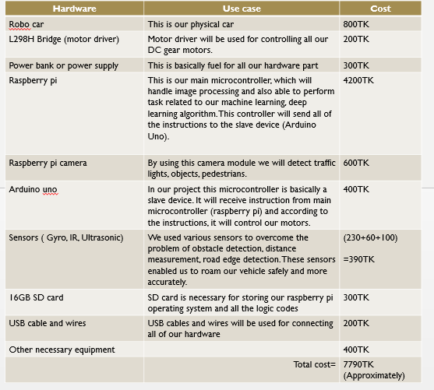

Table 3

## 3.3 Block Diagram

**Dc Motors**

**Sensors**

**Arduino**

**Circuit Board**

**Raspberry** **pi**

**Power Supply**

**Motor Driver**

Figure 3

# Circuit Design and Set Up

## 4.1 Raspberry Pi

The Raspberry Pi is a single board computer. The chip itself is an SOC or system on chip, so it has almost all the parts of a computer on a single die. It also provides a set of GPIO (general purpose input/output) pins that allow you to control electronic components for physical computing and explore the Internet of Things (IoT). The raspberry pi boards are used in many applications like Media streamer, Arcade machine, Tablet computer, Home automation, Carputer, Internet radio, controlling robots. The Raspberry Pi itself is an embedded computer, or also an SBC (single board computer). It is actually a SoC (system on chip), containing multiple dies stacked on top of each other, with a Broadcom BCM 2835/6/7 ARM CPU, a Broadcom VideoCore GPU (graphics processing unit) and RAM all tied together.

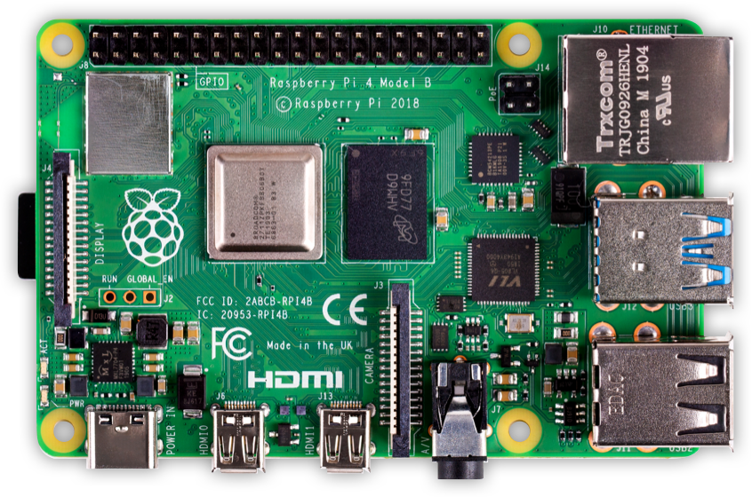

Figure 4: Raspberry pi

In our project this is our main microcontroller, which will handle image processing and also able to perform task related to our machine learning, deep learning algorithm. This controller will send all of the instructions to the slave device (Arduino Uno).

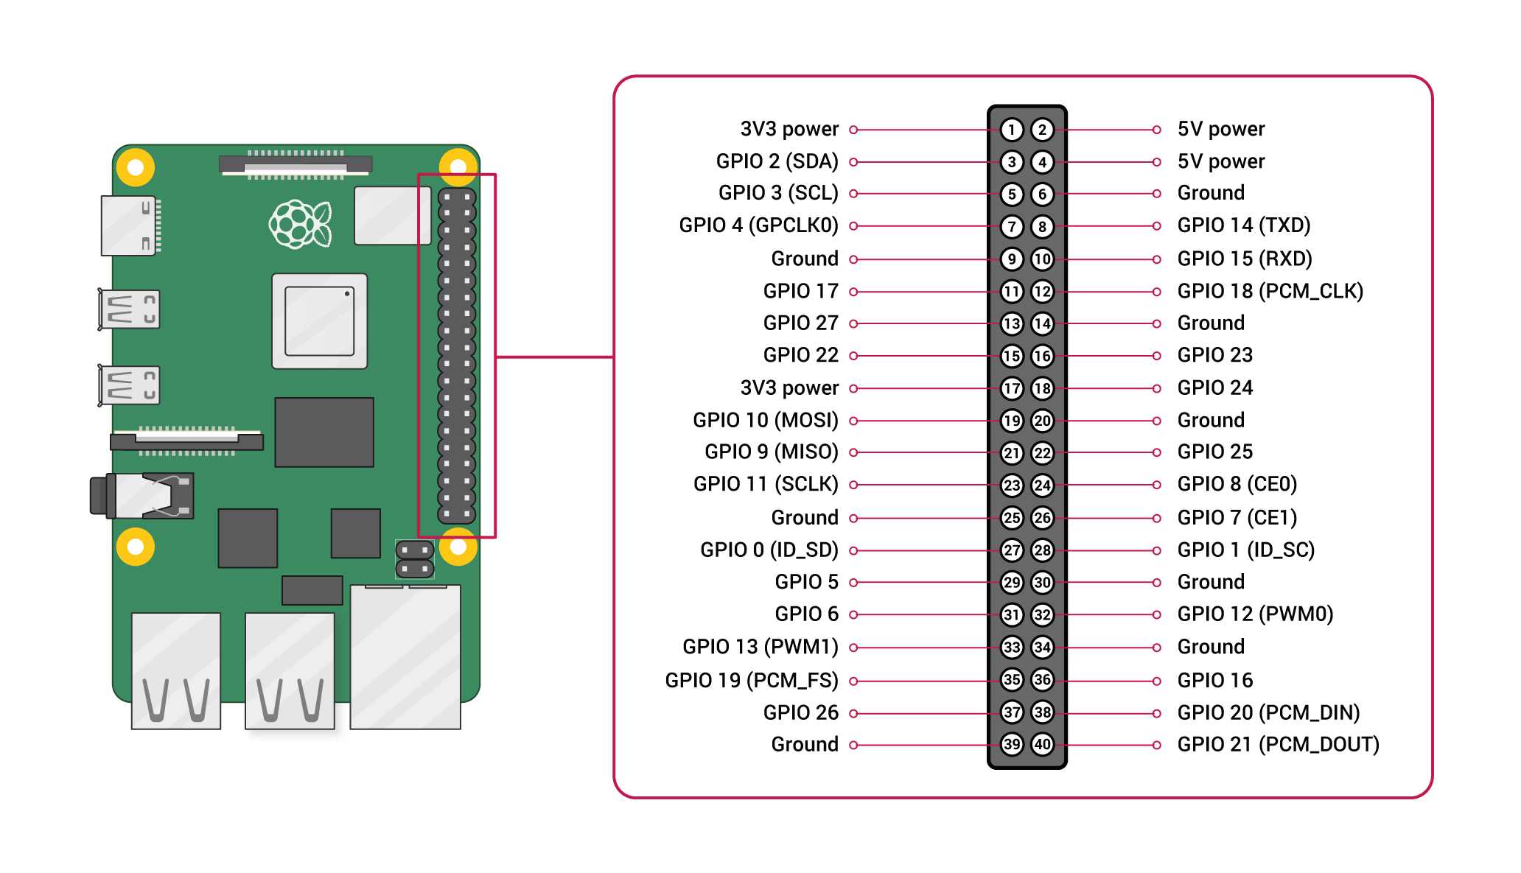

Figure 5: Pin Configuration of Raspberry Pi

## Arduino Uno

Arduino is an open-source prototyping stage in view of simple to-utilize equipment and  
programming. Arduino boards can read inputs. We can advise our board what to do by  
sending a set of directions to the microcontroller on the board. To do as such we utilize the  
Arduino programming dialect (based on Wiring) and the Arduino Software (IDE), based on  
Processing.

In our project this microcontroller is basically a slave device. It will receive instruction from main microcontroller (raspberry pi) and according to the instructions, it will control our motors.

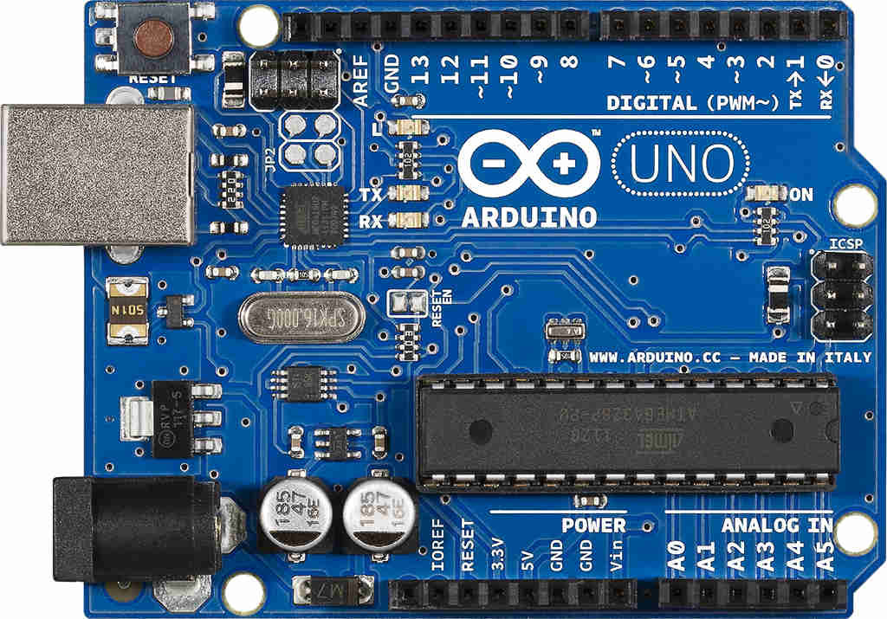

Figure 6

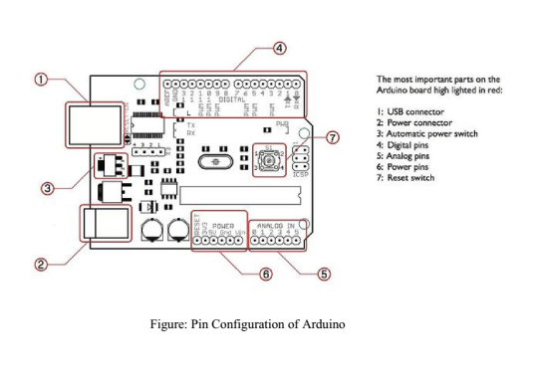

Figure 7

#### Table

**Pin Description**

|  |  |  |
| --- | --- | --- |
| **Pin Category** | **Pin Name** | **Details** |
| Power | Vin, 3.3V, 5V, GND | Vin: Input voltage to Arduino when using an external power source.  5V: Regulated power supply used to power microcontroller and other components on the board.  3.3V: 3.3V supply generated by on-board voltage regulator. Maximum current draw is 50mA.  GND: ground pins. |
| Reset | Reset | Resets the microcontroller. |
| Analog Pins | A0 – A5 | Used to provide analog input in the range of 0-5V |
| Input/Output Pins | Digital Pins 0 - 13 | Can be used as input or output pins. |
| Serial | 0(Rx), 1(Tx) | Used to receive and transmit TTL serial data. |
| External Interrupts | 2, 3 | To trigger an interrupt. |
| PWM | 3, 5, 6, 9, 11 | Provides 8-bit PWM output. |
| SPI | 10 (SS), 11 (MOSI), 12 (MISO) and 13 (SCK) | Used for SPI communication. |
| Inbuilt LED | 13 | To turn on the inbuilt LED. |
| TWI | A4 (SDA), A5 (SCA) | Used for TWI communication. |
| AREF | AREF | To provide reference voltage for input voltage. |

Table 4

We connected the Arduino with computer via USB and used the  
Arduino coding Software to provide the desired instructions to the main board.

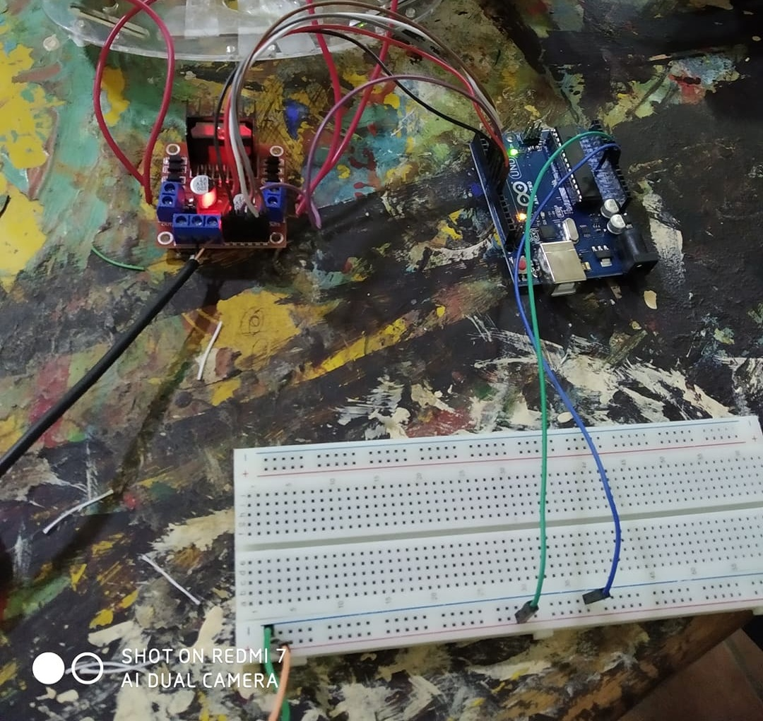

Figure 8: connecting with Arduino Uno

## Sensors:

The sensor also called a transducer is a device that converts one form of energy into another form such as a microphone convert sound into an electrical form or a light sensor gives output according to the intensity of light. Sensors are the key components for perceiving the environment. A sensor is a device that detects and responds to some type of input from the physical environment. The specific input could be light, heat, motion, moisture, pressure, or anyone of a great number of other environmental phenomena.The output is generally a signal that is converted to a human-readable display at the sensor location or transmitted electronically over a network for reading or further processing. In short, a sensor is a device that detects and responds to some type of input from the physical environment such as light, heat, motion, moisture, pressure and used to switch voltages or currents. We used various sensors to overcome the problem of obstacle detection, distance measurement, road edge detection. These sensors enabled us to roam our vehicles safely and more accurately. The sensors we used are:

1. Ultrasonic Sensor
2. Gyro Sensor
3. IR Sensor

### 4.3.1 Gyro Sensor

Inertial sensors make the measurement of the internal state of the vehicle. A major advantage  
of the inertial sensors is that they are non-radiating and non-jumpable and may be packaged  
and scaled from the environment. This makes them partially robust in the harsh conditions.  
The most common application of inertial sensors is in the heading gyro. Integration of the  
gyro rate information provides the orientation of the vehicle. A gyro is the device return an  
output proportional the rotational velocity. Gyro sensor can sense rotational motion and also  
can sense change in orientation. In other word gyro sensor can be defined as the sensing  
device that can detect motion effectively. Gyro sensors, also known as angular velocity  
sensors, are devices that sense angular velocity. Our Human eye can detect motion but  
there are some motion that human eye have difficulty sensing. This is where the Gyro sensor  
comes to work. Good quality gyro sensors have:

1. Zero or constant bias

2. Small noise variance

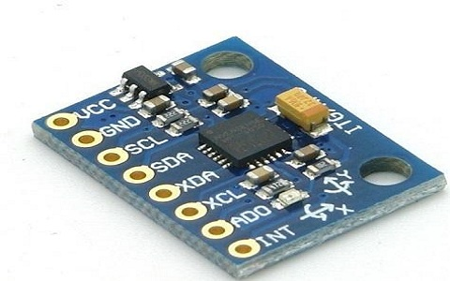

Figure 9: Gyro Sensor

##### Working procedure of Gyro sensor:

Gyro sensors sense rakish speed from the Coriolis power connected to a vibrating component. Now the working procedure is explained using a double-T structure crystal element. Gyro sensor detects vibration produced by external factors and transmits vibration data as electrical signals to a CPU. It can be utilized as a part to correct the orientation or balance of an object. For example Camera-shake correction, Vehicle control. Gyro sensor applications: There are mainly three applications for gyro sensors:

• Angular velocity sensing

• Angle sensing

• Control mechanism

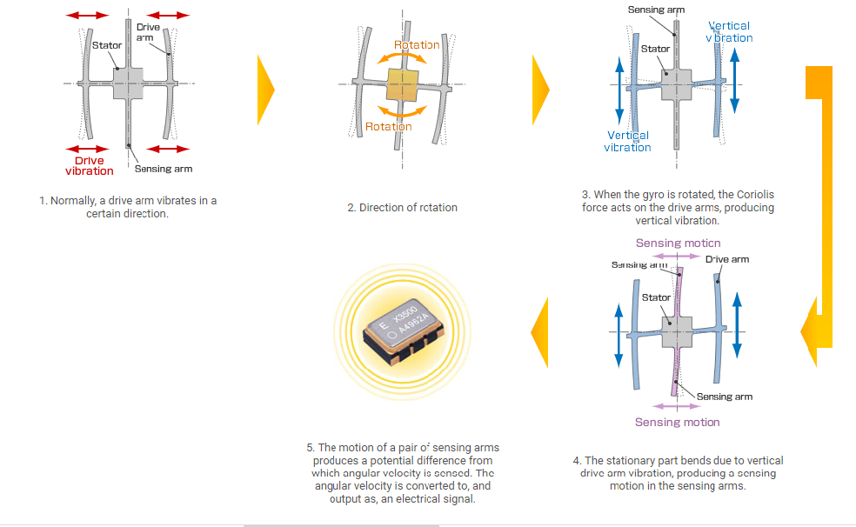

Figure 10: Working Principle of gyro sensor

#### Elements of Gyro sensor:

#### Table

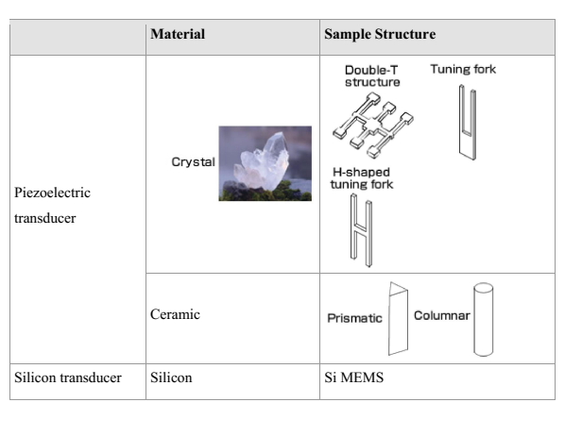

Table 5

### 4.3.2 IR Sensor

This Sensor module deals with the rule of Reflection of Infrared Rays from the occurrence  
surface. A consistent light emission beams is transmitted by the IR LED. At whatever point a  
reflecting surface comes before the Receiver, these beams are reflected back and caught.  
Whenever a retaining surface comes before the Receiver, these beams are consumed by the  
surface and in this manner not able to be caught. So it can be said, this device emits and/or  
detects infrared radiation to sense a particular phase in the environment. Generally, thermal  
radiation is emitted by all the objects in the infrared spectrum. The infrared sensor detects this  
type of radiation which is not visible to human eye.

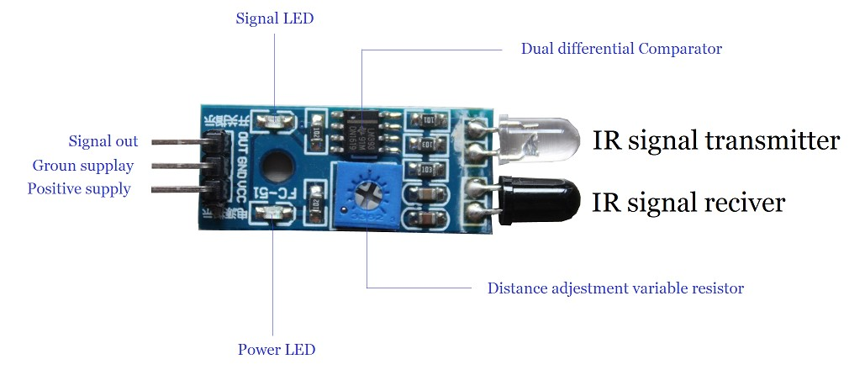

Figure 11

Measuring the distance of the object from the receiver sensor:  
The electrical property of IR sensor components can be used to measure the distance of an  
object. The fact when IR receiver is subjected to light, a potential difference is produced  
across the leads. The basic idea is to make use of IR LEDs to send the infrared waves to the object. Another IR diode of the same type is to be used to detect the reflected wave from the object. The diagram is shown below.

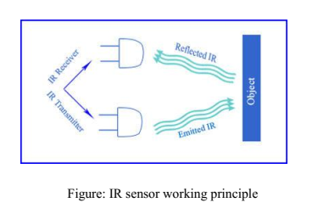

Figure 12

When IR receiver is subjected to infrared light, a voltage difference is produced across the  
leads. Less voltage which is produced can be hardly detected and hence operational  
amplifiers (Op-amps) are used to detect the low voltages accurately.

### 4.3.3 Ultrasonic Sensor

SONAR stands for Sound Navigation and Ranging, was initially developed for underwater  
application. The Sonar Sensor is a compact high performance ultrasonic rangefinder that  
transmits ultrasonic waves into the air and identifies reflected waves from an object. There  
are numerous applications for ultrasonic sensors, for example, in intrusion alarm systems,  
programmed entryway openers and reinforcement sensors for vehicles. Joined by the fast  
improvement of data handling innovation, new fields of use, for example, factory automation  
equipment and car electronics are increasing and should continue to do so. The sensor  
automatically calibrates itself when powered up.

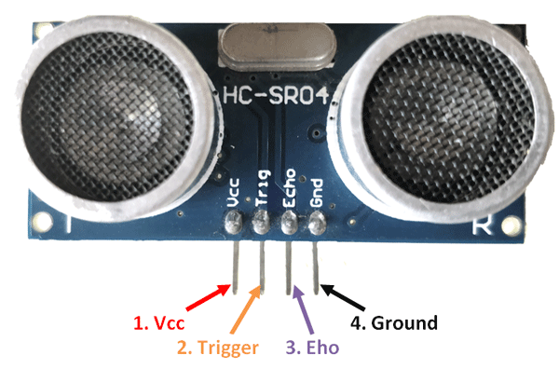

Figure 13

Utilizing its remarkable piezoelectric ceramic fabricating innovation created over numerous  
years now days we have ultrasonic sensors which are minimized but have superior. Sonar is  
an ultrasonic sensor that uses electrical and mechanical energy transformation to measure the  
distance from the sensor to the target object. It consists of a transmitter and receiver which  
are available as separate units or embedded together as a single unit.

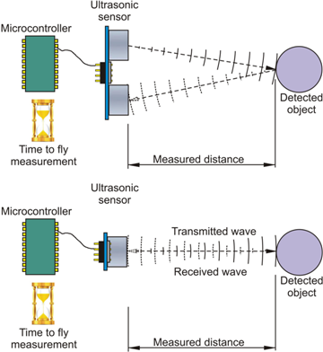

Figure 14

This sensor consists of four pins:

* VCC-connect to the 5v DC
* Trigger- Pulse input that triggers the sensor
* Echo-Indicates the reception from the target.
* Gnd- Ground.

### 4.3.4 Power Bank

The power supply pulls the required amount of electricity and converts the AC current to DC current. For our project we used two power banks. This is basically the fuel for all the hardware parts.

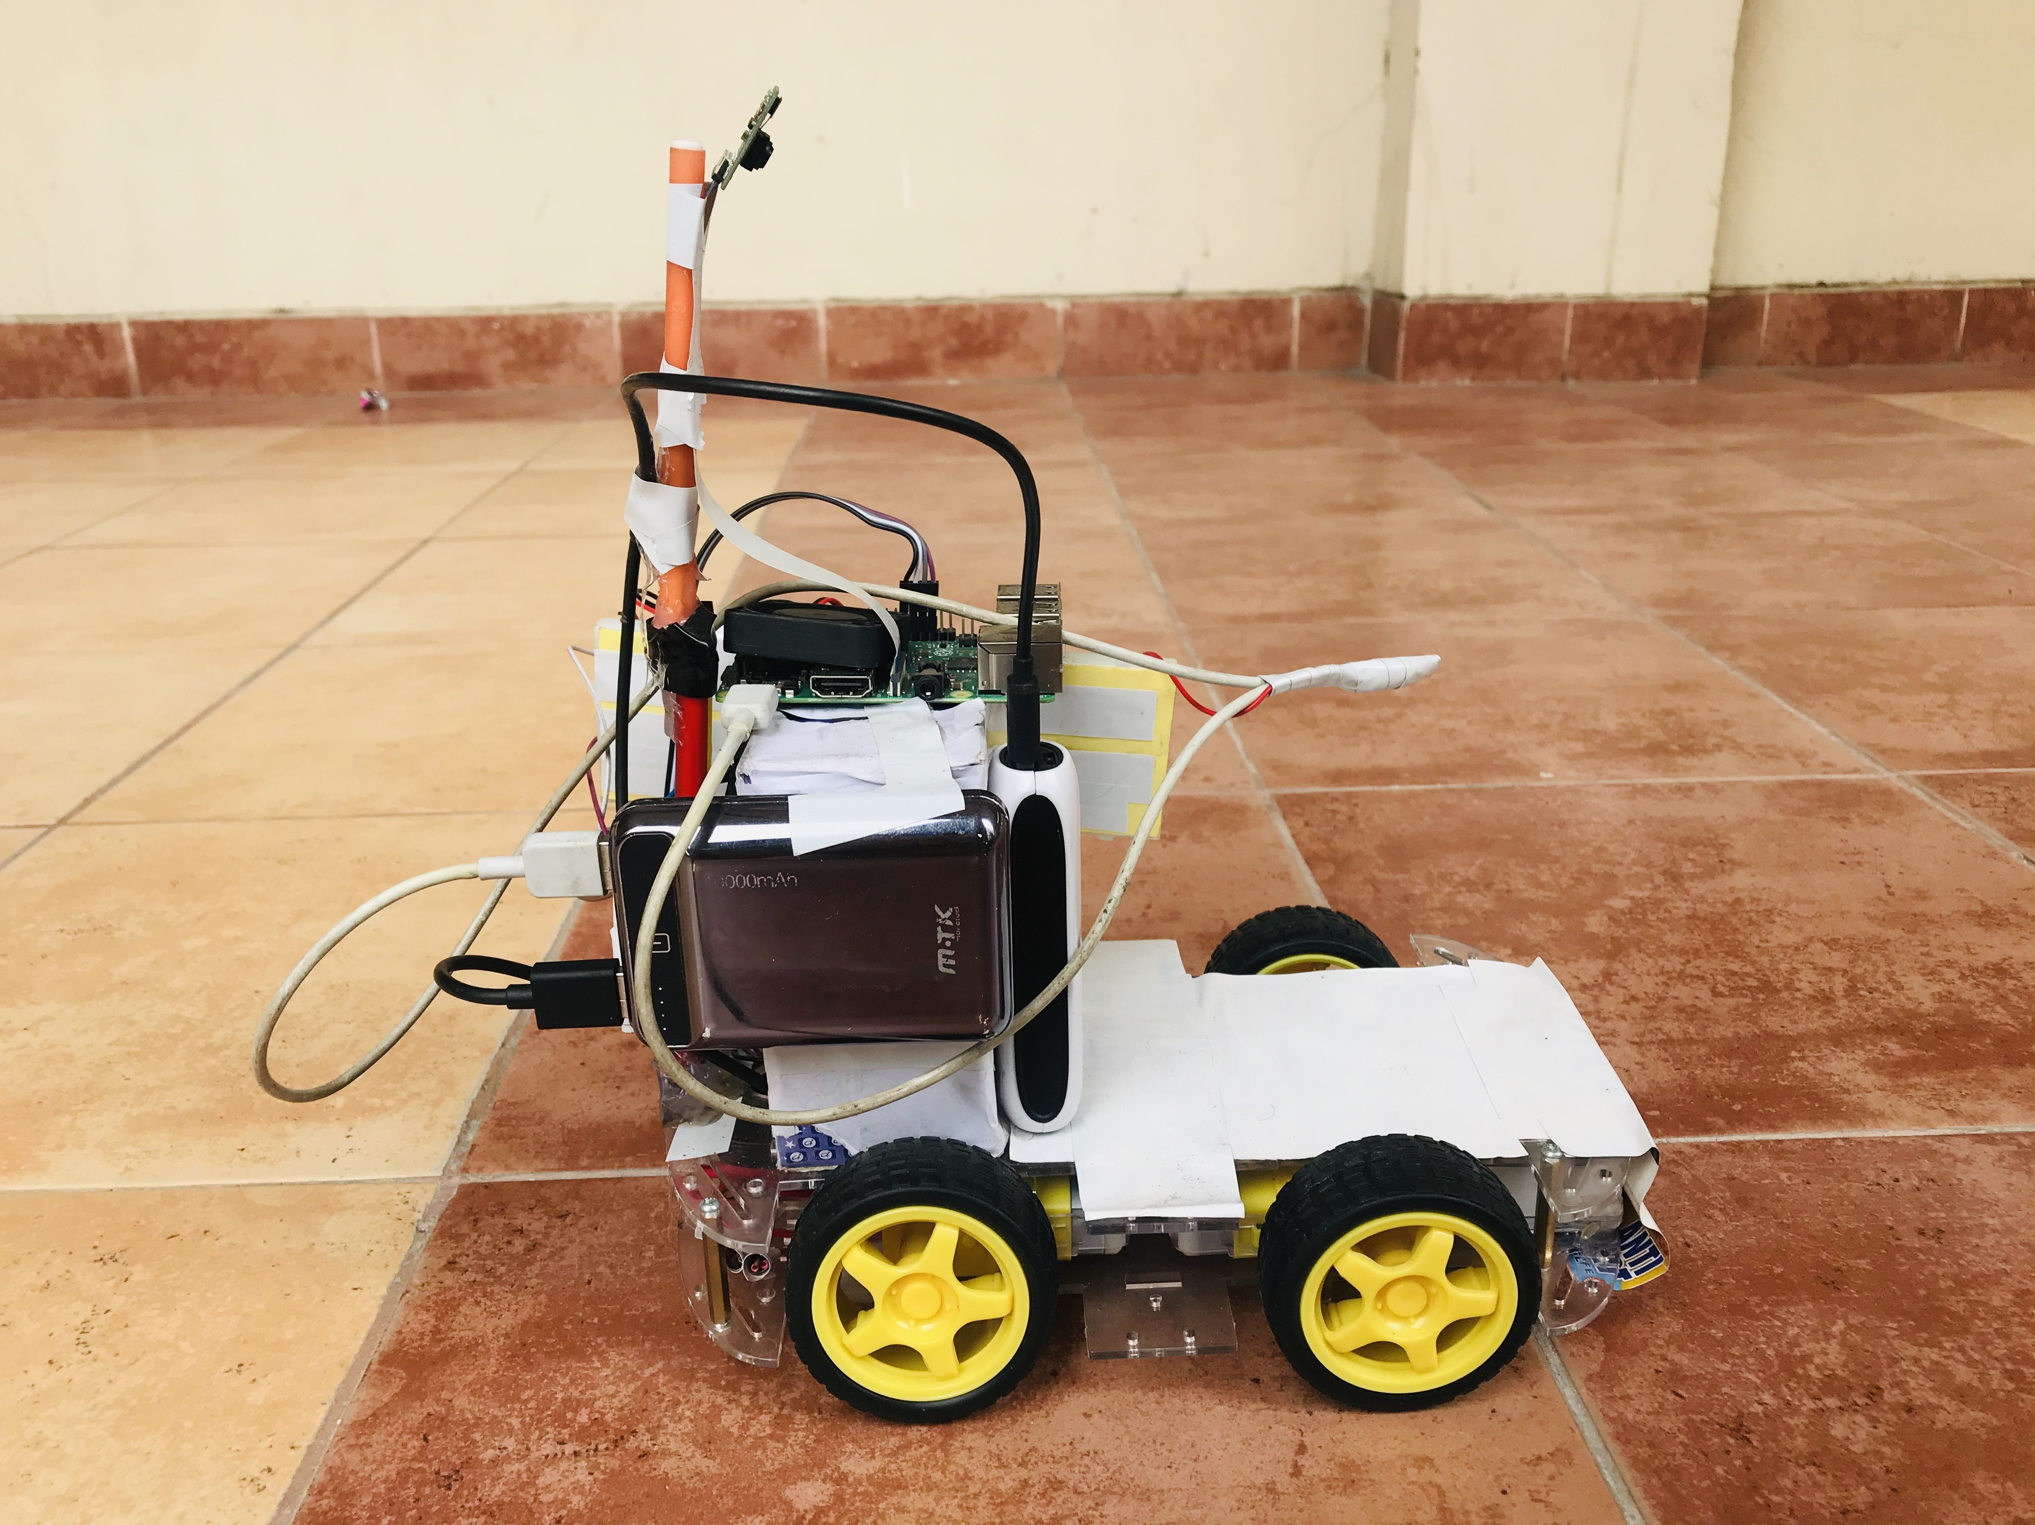

Figure 15

### 4.3.5 Motor Driver L298H Bridge

The L298 Driver is a high voltage, high current dual full bridge driver designed to accept standard TTL logic levels and drive inductive loads such relays, solenoids, DC and stepping motors. Two enable inputs are provided to enable or disable the device independently of the input signals. For controlling the rotation direction, we just need to inverse the direction of the current flow through the motor, and the most common method of doing that is by using an H-Bridge.

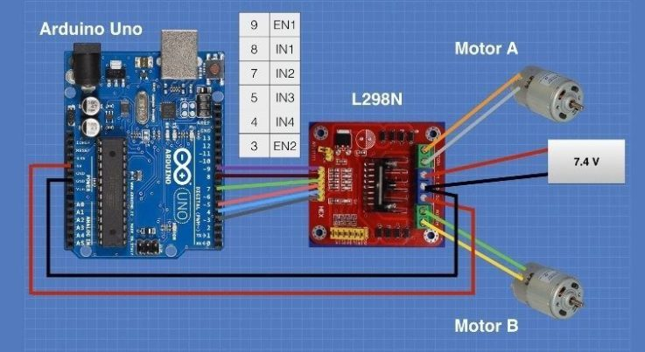

Figure 16

The module can drive DC motors that have voltages between 5 and 35V, with a peak current up to 2A. The module has two screw terminal blocks for the motor A and B, and another screw terminal block for the Ground pin, the VCC for motor and a 5V pin which can either be an input or output. This depends on the voltage used at the motors VCC.

The module have an onboard 5V regulator which is either enabled or disabled using a jumper. If the motor supply voltage is up to 12V we can enable the 5V regulator and the 5V pin can be used as output, for example for powering our Arduino board. But if the motor voltage is greater than 12V we must disconnect the jumper because those voltages will cause damage to the onboard 5V regulator. In this case the 5V pin will be used as input as we need connect it to a 5V power supply in order the IC to work properly. The Enable A and Enable B pins are used for enabling and controlling the speed of the motor. If a jumper is present on this pin, the motor will be enabled and work at maximum speed

### 4.3.6 Raspberry Pi Camera

By using this camera module we will detect traffic lights, objects, pedestrians. The Pi camera module is a portable light weight camera that supports Raspberry Pi. It communicates with Pi using the MIPI camera serial interface protocol. The camera board attaches to the Raspberry Pi via a 15-way ribbon cable. There are only two connections to make: the ribbon cable needs to be attached to the camera PCB, and to the Raspberry Pi itself.

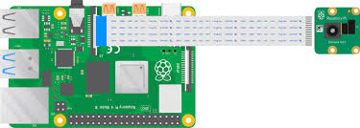

Figure 17

### 4.3.7 Additional protection circuit

The circuit helps to protect the raspberry pi when motor draws large amount of current. The raspberry pi keeps rebooting again and again so the capacitor store some charge and solve the problem.

### 4.3.8 The overview of set up connection

Our system is based on mainly two parts: Electrical and software. The  
whole process is controlled by linking Raspberry pi and Arduino with sensors and camera. Arduino get the coordinates from the sensors and send the coordinates to the mechanical part which includes a digital a motor controller and dc motors which are connected to four wheels of the car. The orientation of the wheels are decided by the cross connection of the dc motors. The camera helps in image processing unit with the help of sensors which measures the distance among objects. We used censor for the direction purpose. It works like a compass to control the desired direction of our vehicle. Several other sensors have been used too.

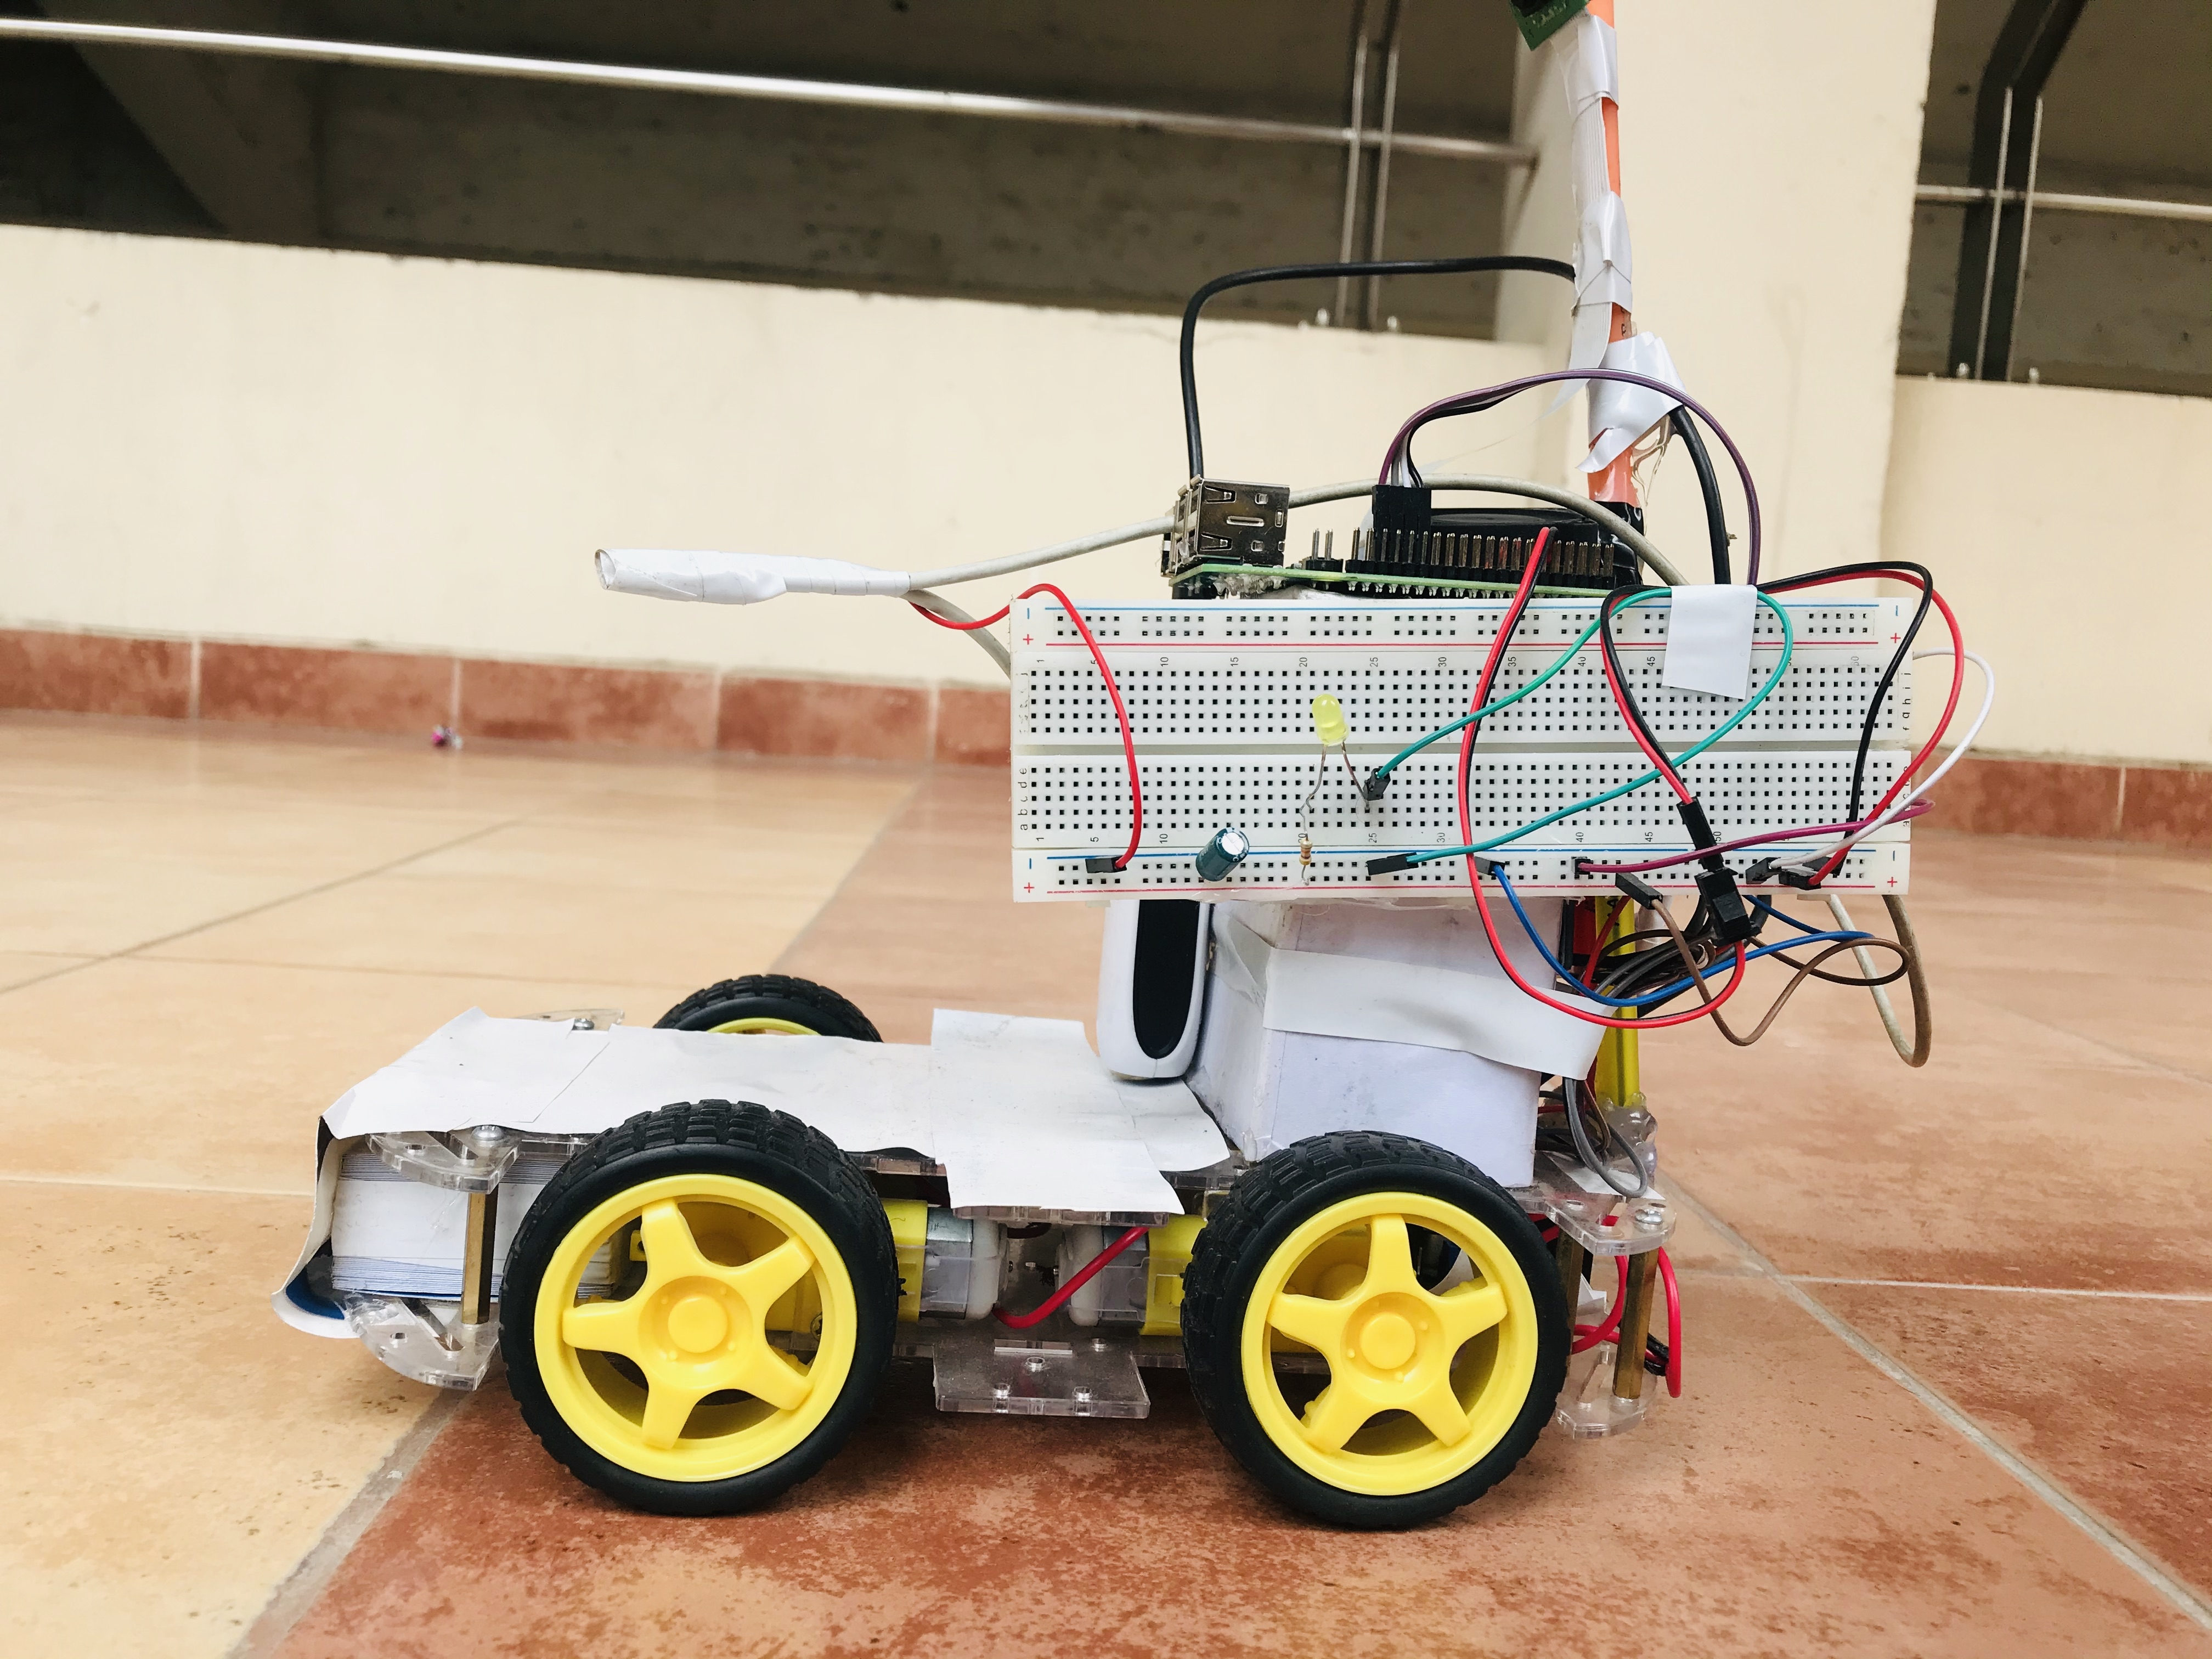

Figure 18

1. Methodology

Further improvements in the hardware platform will give better results in obtaining GPS data accurately and synchronizing simultaneously

with the Arduino. While working on this research project, we studied various research papers related to our project topic and picked a few papers related to our topic. We chose these particular papers because their working approach is closely related to our research work. We also deduced some ideas from there for doing our work.

# Result

## 6.1 Result

## Though, it is difficult to implement this project with a limited budget. To obtain precise and accurate results LASER sensors are required. These kinds of sensors are pretty much expensive, which is a drawback. In future works, if the laser sensor named “LIDAR” is used, surely the results will have very few errors. With a limited budget in our project, we faced so many problems during testing the autonomous car but finally, we successfully built the car. Our work was more of a prototype. After final work is done the car was able to detect obstacles and move according to it. For detecting purpose we used built-in mobileNet version-2 which was very efficient and easy to integrate with our project. This library is very powerful for detecting any kind of object almost perfectly, Its has 90 built-in features for object detection.

## 6.2 Problems We Faced

As our project focuses on autonomous driving, implementation was not very easy task. We  
faced quite a few problems during our thesis work. There is always an error and some fluctuation occurs. When to move and how much to move, sometimes the car could not make the decision. We faced problem while measuring the distance from the object on which the car would act on, so we used IR and ultrasonic sensors to solve the problem.

Another problem we faced was obstacle detection. As this is an autonomous vehicle, it is a must for us to ensure the obstacle detection system is working correctly. We used Ultrasonic sensors and IR sensors for this purpose and build in method mobilenet version-2. Though we couldn’t be as precise as we wanted to be, still it helped us to have a safer driving of our car. Sometimes we get paranoid, when after trying so many times the car didn’t run. But finally we was able to make the car run properly.

7 Discussion

From the previous sections, we know that the experimental prototypes of the self-driving car have been developed, some typical self-driving cars have been tested on more than one million kilometers, and the test for driving license for a self-driving car has been issued by some states in USA . However, we should know that the realization of self-driving car is not only influenced by the self-driving car technology, but also by the vehicle cost, social habits, human psychology, law and so on; therefore, there will be a long way to go for the entire commercialization of self-driving car.

8 Conclusion

It needs time for the social habit of humans to accept the self-driving car, for instance, the share of self-driving car among the people, the development of automatic supporting facilities for self-driving car energy compensation, the human psychological acceptance degree for self-driving car, and the development of law to deal with the traffic accident on self-driving car. With the limited budget, we tried to build this project which can serve in many zone, specially industrially and for people who have difficulties in driving. It can be very useful in industrial areas where working is dangerous for people, it can transport goods from one place to another place. With the rapid development of technology, autonomous driving is now a very promising  
feature of the motor vehicle industry. Specially in Bangladesh this kind of autonomous  
research has not been developed much. Autonomous vehicle can be a big step in the  
technological advancement of our country. This project shows significant promise as a  
platform for the development of autonomous driving technology and it is anticipated that  
with development of the underlying systems completed future work will focus on refining  
and improving the methods presented here. If our government and private investors have the  
willingness to grant fund this field of research, it would be a very propitious sector.

9 References

# Bibliography

(n.d.). Retrieved from Digital Trends: https://www.digitaltrends.com/cars/history-of-self-driving-cars-milestones/

*A brief history of autonomus vehicle technology*. (n.d.). Retrieved from WEIRED: https://www.wired.com/brandlab/2016/03/a-brief-history-of-autonomous-vehicle-technology/

Davies, A. (2018, December 13). *The WIRED Guide to Self-Driving Cars*. Retrieved from WIRED: https://www.wired.com/story/guide-self-driving-cars/

Jianfeng Zhao, B. L. (n.d.). *The key technology toward the self driving car*. Retrieved from Emerald Insight: https://www.emerald.com/insight/content/doi/10.1108/IJIUS-08-2017-0008/full/html

*WHAT IS AN AUTONOMOUS VEHICLE?* (n.d.). Retrieved from TWI: https://www.twi-global.com/technical-knowledge/faqs/what-is-an-autonomous-vehicle